Insert :
60
65
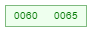
25 : split 60
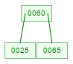
50
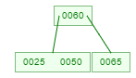
55 : Split 50
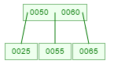
40
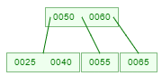
30 : split 30, Split 50
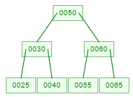
15
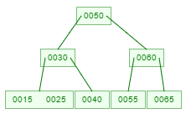
20
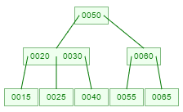
Del :
15 : P(20) Merge Sr (25)
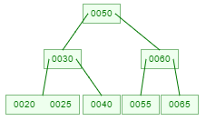
50 : replaced by predecessor (40), x <- P (30) <- SL (25)
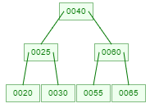
65 : SL(55) merge P(60), SL(25) merge P(40)
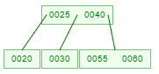
25 : SL (20) replace, merge P(20), SR(30)
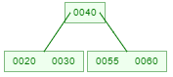
20
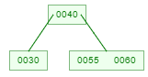
30 : <- P(40) <- SR(55)
